**Birla Institute of Technology and Science Pilani, Dubai Campus**

**Dubai International Academic City**

**CS/ECE/INSTR/EEE F241**

**MICROPROCESSORS AND INTERFACING**

**LABORATORY MANUAL**

**II Semester 2021-22**

**CYCLE I**

**EXPERIMENT 2**

**P1. Write a program to add two multi-byte binary numbers stored in memory and**

**also store the result in memory.**

**Handwritten code/program:**

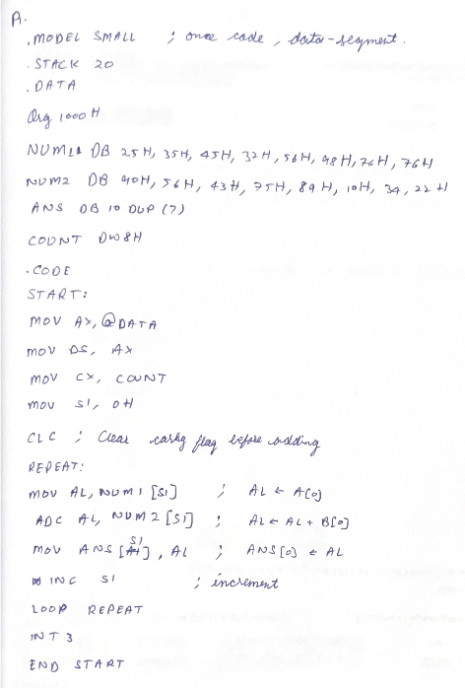

**Result:**

Array 2

result

Array 1

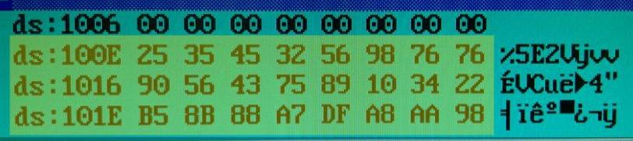

**P2. Write a program to subtract two multi-byte binary numbers stored in memory**

**and also store the result in memory.**

**Handwritten code/program:**

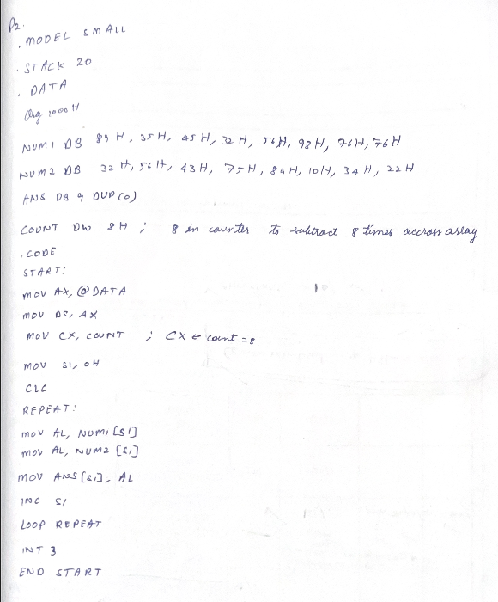

**Result:**

Array 2

result

Array 1

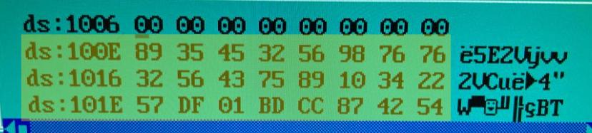  
  
**P3. Write a program to multiply two 8-bit binary numbers stored in memory and also**

**store the result in memory (both unsigned and signed operation).**

**\*\* Unsigned numbers stored only positive numbers but not negative numbers**

**\*\* Signed numbers contain sign flag,**

**Handwritten code/program:**

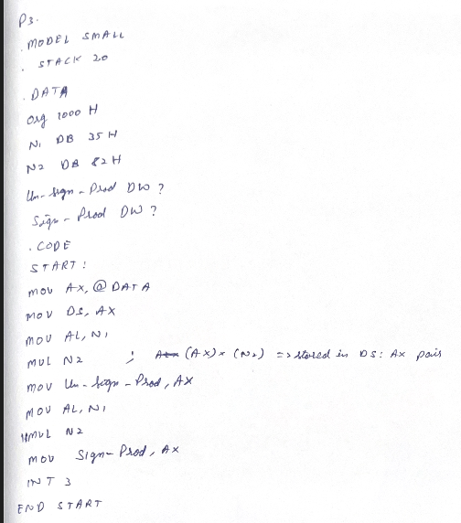

**Result:**

Upper byte 2

Lower Byte 1

Upper byte 1

Num 2

Num 1

Lower Byte 2

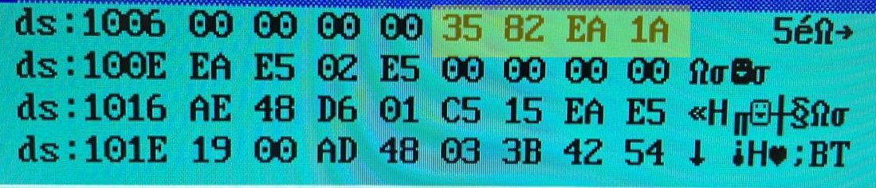

**\*\*\*\*\*\*\*\*\*\*\*\*\*\*\*\*\*\*\*\*\*\*\*\*\*\*\*\*\*\*\* Assignment Problem \*\*\*\*\*\*\*\*\*\*\*\*\*\*\*\*\*\*\*\*\*\*\*\*\*\*\*\*\*\***

**Q2. Write a program to find factorial of number.**

**Handwritten code/program:**

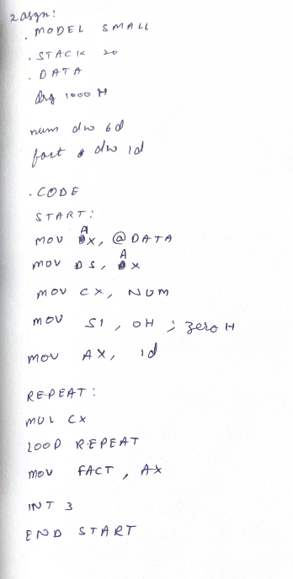 **Result:**

Num 1

lower byte

Lower

Byte

Upper

Byte

Num 1

Higher byte

Num 1

Higher byte

